**Record of Ex. No: 10 – Geometric Dimensioning and Tolerance**

**Date of experiment:** 05.07.2021 **Date of submission: 05.07**.2021

**Name:** Kunal Keshan S **Department:** ECE – A **Roll No:** RA2011004010051

**Aim:**

To learn and understand the importance of Geometric Dimensioning and Tolerance.

**Software used:** AutoCAD.

**Procedure:**

|  |  |
| --- | --- |
| Commands Used | Purpose of Command |
| UNITS | To set the units of the drawings. |
| LIMITS | To set the limits of the drawing area. |
| ZOOM | To adjust the view of the drawing area. |
| LINE | Used to draw a line. |
| POINT | Used to place a point on the drawing area. |
| TEXT | Used to add text in the drawing area. |
| TEXTEDIT | Used to edit any existing text. |
| DIMLINEAR | Used to add linear dimensions. |
| DIMALIGNED | Used to add aligned dimensions (i.e parallel to a line or point that is not perpendicular) |
| DIMANGLE | Used to add dimensions between any two lines or arcs. |
| DDPTYPE | Used to set the type of point and its size. |
| POLYGON | Used to draw a polygon of required number of sides, either inscribed in a circle or the circle in the polygon. Or the polygon can be drawn with respect to its edge length. |
| TRIM | Used to trim off unnecessary parts of the drawing. |
| LEADER | They are used to create leaders from any point or feature of a drawing. Leaders can be straight line segments or smooth spline curves. |
| MLEADER | A multileader object, or a mleader, comprises a leader and a note. |
| TOLERANCE | Used to set the required tolerance for the objects drawn. |

**Steps:**

1. Adjust the right units and limits of the drawing area using UNITS AND LIMITS.
2. Go to Annotate Tab and select the leader’s options on the bottom right corner of the leader section.
3. Select the modify Option available on the right side. Then go to the Leader Format tab and select the arrowhead symbol as Datum Triangle Filled.
4. Next go to the content tab and make sure that the Frame text checkbox is checked. Click Ok and then Select Set Current before exiting.
5. Next go to Dimensions options on the bottom right corner of the dimension section.
6. Select the modify option and go to the Text Tab and select the Horizontal Option for the text display.
7. Using the LEADER and MLEADER command set the required lines and notes.
8. Use the TOLEARANCE command to set and draw the tolerance information for the draw objects.

**Question 1:**

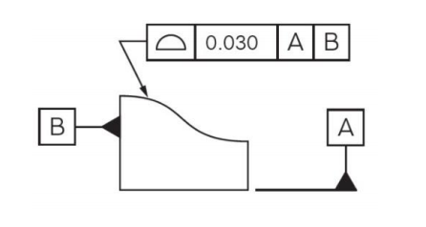

Answer:

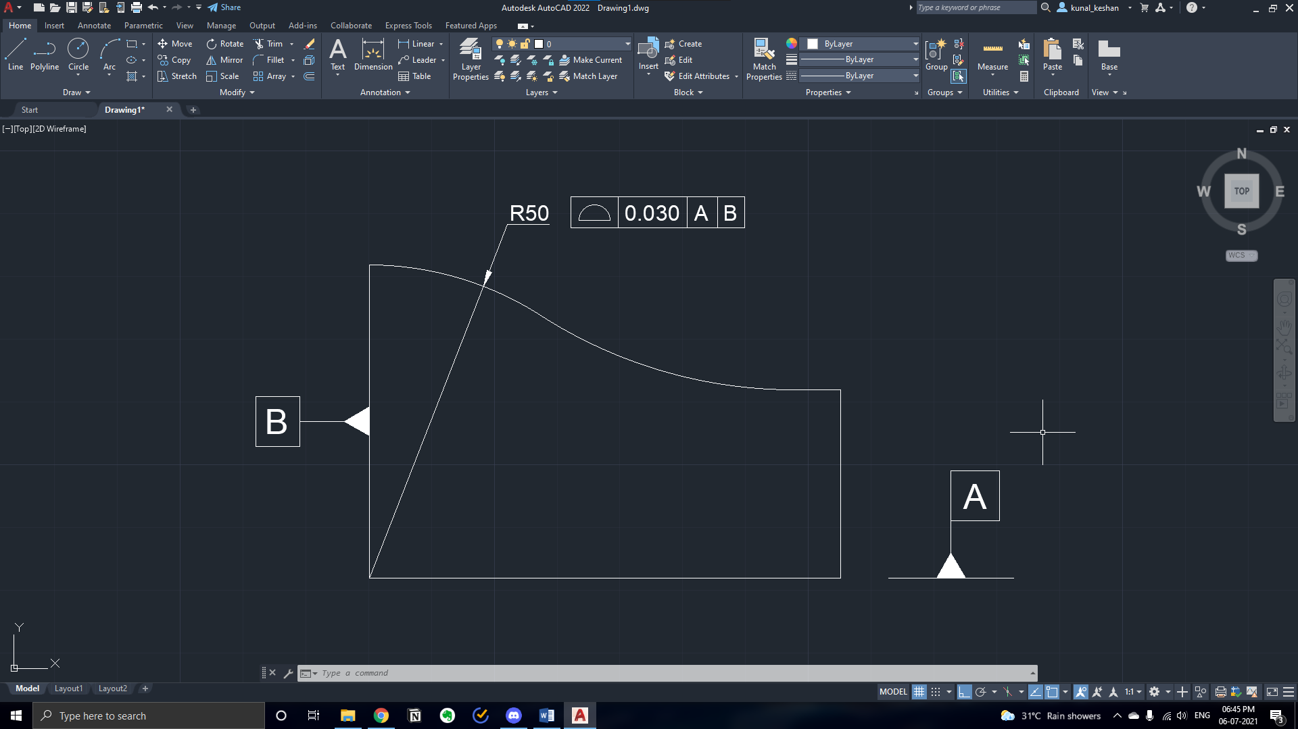

**Question 2:**

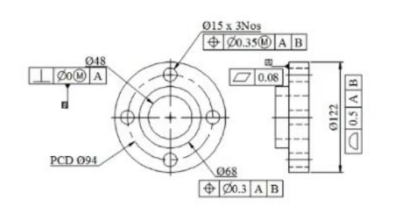

Answer:

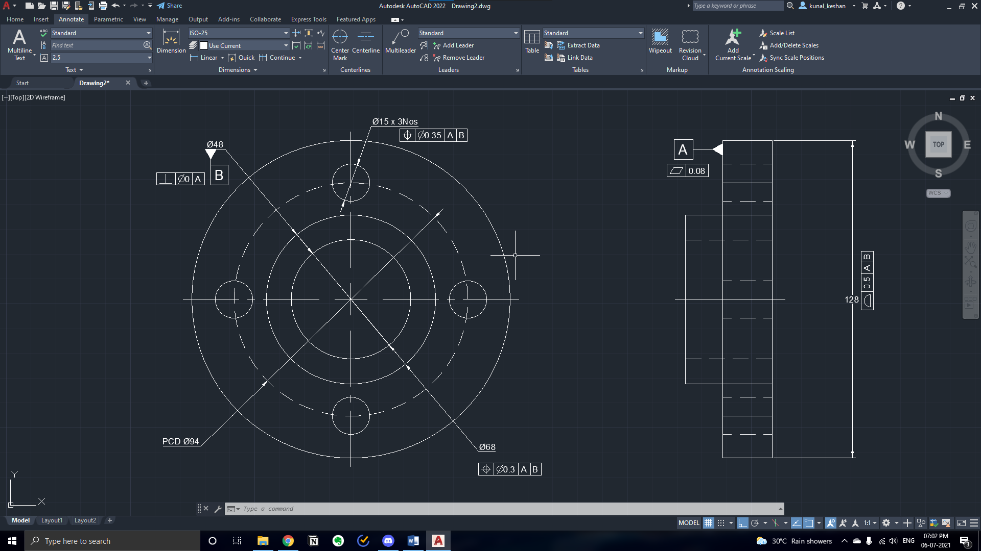

**Result:**

Geometric Dimensioning and tolerance was understood with the help of various diagrams and figures using AutoCAD.